**COAL LAB 5**

**Question 1**

Include irvine32.inc

.data

result DWORD ?

str1 BYTE "The first 10 fibonnaci numbers are: ", 0

.code

main PROC

MOV eax, DWORD ptr 1

MOV ebx, DWORD ptr 0

MOV ecx, 10

MOV edx, OFFSET str1

CALL WriteString

CALL Crlf

target:

ADD eax, ebx

MOV result, eax

call WriteDec

MOV eax, ebx

MOV ebx, result

call CRLF

loop target

exit

main ENDP

end main

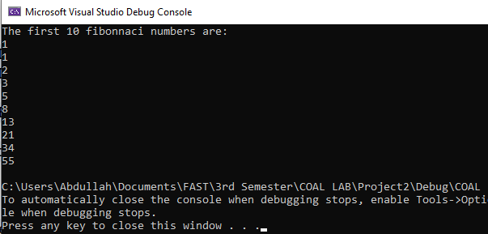

**Question 2**

Include Irvine32.inc

.data

arr1 DWORD 8,5,1,2,6

.code

main PROC

MOV esi, OFFSET arr1

MOV ecx, 5

MOV edx, dword ptr 0

L1:

MOV edi, esi

MOV eax, [esi]

MOV ebx, ecx

L2:

cmp [edi], eax

JGE around

call swap

around:

ADD edi, 4

loop L2

ADD esi, 4

MOV ecx, ebx

Loop L1

MOV ecx,5

MOV esi, OFFSET arr1

print:

MOV eax, [esi]

call WriteDec

Call crlf

ADD esi, 4

loop print

exit

swap:

MOV edx, eax

MOV eax, [edi]

MOV [edi], edx

MOV [esi], eax

ret

main endp

end main

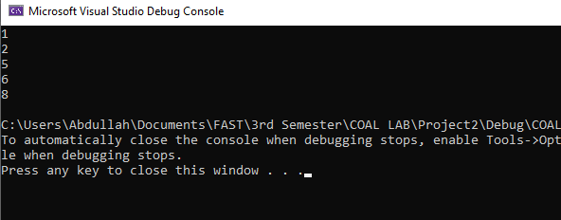

**Question 3**

**a)**

Include Irvine32.inc

.data

count DWORD 1

.code

main PROC

MOV ecx, 4

MOV eax, 1

a1:

MOV edx, ecx

MOV ecx, count

a2:

call WriteDec

loop a2

call crlf

inc count

MOV ecx, edx

loop a1

exit

main endp

end main

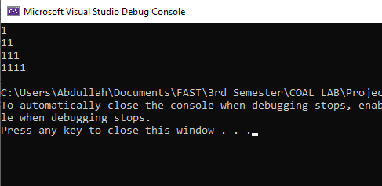

**b)**

Include Irvine32.inc

.data

count DWORD 4

.code

main PROC

MOV ecx, 4

MOV eax, 1

a1:

MOV edx, ecx

MOV ecx, count

a2:

call WriteDec

loop a2

call crlf

dec count

MOV ecx, edx

loop a1

exit

main endp

end main

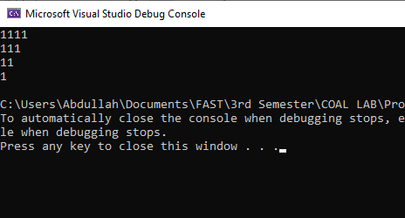

**c)**

Include Irvine32.inc

.data

count DWORD 4

.code

main PROC

MOV ecx, 4

a1:

MOV edx, ecx

MOV ecx, count

MOV eax, 4

a2:

call WriteDec

dec eax

loop a2

call crlf

dec count

dec eax

MOV ecx, edx

loop a1

exit

main endp

end main

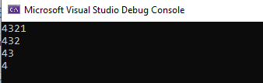

**d)**

Include Irvine32.inc

.data

count DWORD 4

.code

main PROC

MOV ecx, 4

a1:

MOV edx, ecx

MOV ecx, count

MOV eax, 1

a2:

call WriteDec

inc eax

loop a2

call crlf

dec count

MOV ecx, edx

loop a1

exit

main endp

end main

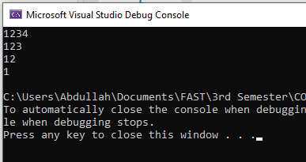

**Question 4**

INCLUDE Irvine32.inc

.data

ID1 BYTE "Enter your employee ID: ", 0

Name1 Byte "Enter your name: ", 0

Birth BYTE "Enter your date of birth: ", 0

Salary1 BYTE "Enter your salary: ", 0

ID DWORD 5 DUP(?)

temp BYTE 25 DUP(0)

DOB DWORD 5 DUP(?)

SALARY DWORD 5 DUP(?)

print BYTE "TOTAL ANNUAL SALARY: ",0

.code

main PROC

mov ecx,5

mov esi,0

L1:

MOV edx, OFFSet ID1

call WriteString

call ReadDec

mov ID[esi], eax

call Crlf

MOV edx, OFFSet Name1

call WriteString

mov edx, OFFSET temp

call ReadString

MOV edx, OFFset Birth

call Writestring

call ReadDec

mov DOB[esi],eax

call Crlf

MOV edx, OFFSet salary1

call WriteString

call ReadDec

mov SALARY[esi],eax

call Crlf

add esi,4

loop L1

mov ecx,5

mov eax,0

mov esi,0

L2:

add eax,SALARY[esi]

add esi,4

Loop L2

mov edx,OFFSET print

call writestring

call WriteDec

exit

main ENDP

END main

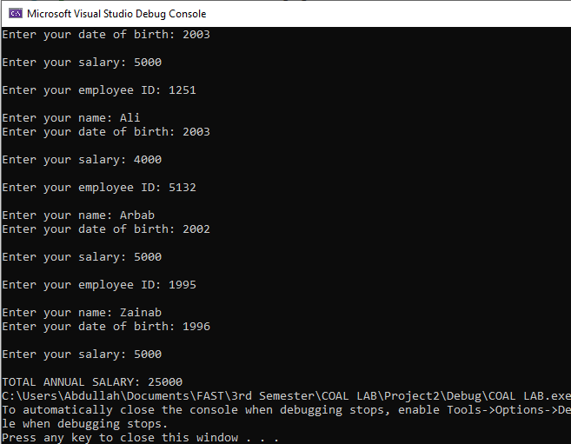

**Question 5**

INCLUDE Irvine32.inc

.data

source byte "helloworld",0

target byte 12 dup(?)

.code

main PROC

mov esi, 0

mov ecx, LENGTHOF source

str1:

mov al,source[esi]

mov target[esi],al

inc esi

loop str1

mov edx, offset target

call writestring

exit

main ENDP

END main

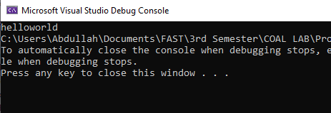

**Question 6**

Include Irvine32.inc

.data

arr1 DWORD 5, 6, 1, 63, 12, 9, 3

.code

main PROC

MOV esi, 0

MOV edi, sizeof arr1

SUB edi, 4

target:

MOV eax, arr1[esi]

XCHG arr1[edi], eax

MOV arr1[esi], eax

ADD esi, type arr1

SUB edi, type arr1

cmp esi, edi

JNE target

MOV ecx, 7

MOV esi, OFFSET arr1

l1:

MOV eax, [esi]

call WriteDec

call crlf

ADD esi, type arr1

loop l1

exit

main endp

end main

